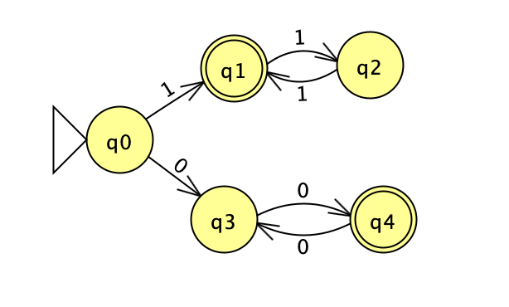this DFA only accepts an even number of zeros OR and odd number of ones.

Since we do not have an incoming input to q0, q0 can be written as

q0 = epsilon I

let’s proceed to the final state of q1,

q1 = q01 + q21 II

q2 = q11 III

q3 = q00 + q40 IV

q4 = q30 V

Now, we can expand

q1 = q01 + q21

q1 = epsilon + q01 + q21

q1 = epsilon + q01 + q11

R = QRR\* by Arden's theorem

q1 = epsilon (q11 + q11)\*

q1 = (q11 + q11)\*

1\*(01\*01\*)*+ |* 0\*10\*(10\*10\*)\*